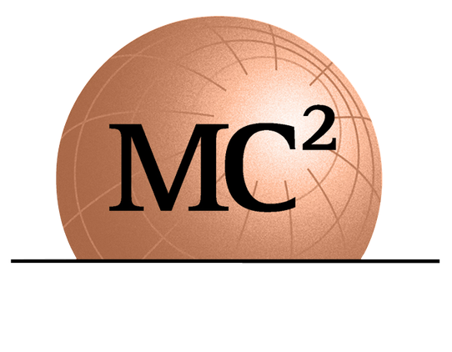
1275 SHILOH ROAD NW SUITE 2620
KENNESAW, GA 30144
RSADLER@MC2ENGINEERS.COM
WWW.MC2ENGINEERS.COM

Job Title: Project Administrator/Accountant

Kennesaw, Georgia

Love Where You Work
Here at MC Squared, we know just how important it is to have a deliberate company culture with deep roots. We encompass safety, a positive attitude and a commitment to exceptional work quality in our day-to-day efforts; we take pride that our core values are Safety, Quality and a "Can-Do" attitude as we maintain our healthy and creative work environment. Our goal is to grow these roots for our next generation of likeminded professionals who embrace these values. That is why at MC Squared, our most important pillar is our people. We have a remarkable executive leadership team that will inspire and challenge you to learn and grow while you mentor our future generation of engineers and leaders. If you’re looking for a place to grow your career MC Squared’s strategic leadership, employee benefits, positive culture, and development opportunities are a great choice to spend the rest of your career.

About Us
MC Squared is a professional consulting engineering firm specializing in the fields of Geotechnical Engineering, Geo-Environmental, Construction Materials Testing and Inspection and Pavement Design and Management with offices in Florida, Georgia, and South Carolina. Our clients include DOT's, municipalities, state agencies and large multi-national engineering and construction firms. We are retained to provide innovative solutions to complex subsurface issues to support the design of heavy civil infrastructure projects in the Transportation, Water/Wastewater, Tunneling, Dams and Aviation sectors. MC Squared has experienced 30% growth year-over-year for the last several years and our current in-house projects and backlog show the trend will continue.

Project Administrator/Accountant Job Responsibilities
- Project setup in Deltek
- Prepare draft project invoicing
- Maintaining Certificates of Insurance for projects
- Managing subcontractor agreements
- Client prequalification’s and renewals
- Maintaining/Updating Safety manuals
- Assisting the team with administrative tasks
- Facilitating the project Contracts/Task Orders/Agreements review process by legal and obtaining executive management approval
- Assist Accounting Manager with basic accounting support functions
Company Perks + Benefits
In addition to offering competitive compensation, our employee benefits package includes:

- Four (4) Medical Plans effective first of the month following start date ($200/Mo. company paid)
- Dental Plan
- Vision Plans (50% Company Paid)
- Health Saving Accounts (HSA)
- Retirement Plan: 401(k) (3% Company Contribution)
- Short Term Disability (100% Company Paid)
- $50,000 Life Insurance (100% Company Paid)
- Accident Insurance (50% Company Paid)
- Critical Illness Insurance (50% Company Paid)
- GAP Insurance
- Bonus Program
- Eight (8) Paid Holidays
- Paid Sick and Vacation Time
- Professional development training
- Professional certification and registration renewals

Requirements
- Ideal candidates will be degreed in accounting with 3+ years in Project Accounting
- Strong Excel & MS experience
- Experience with Deltek is a plus
- Experience in project invoicing and billing
- Strong oral and written communication skills.
- Excellent work ethic.

How to Apply
Please send your resume via e-mail to rsadler@mc2engineers.com. This is a full-time position housed in our office in Kennesaw, Georgia. Must be authorized to work legally in the US.

EEO Statement
We are an Equal Opportunity Employer and do not discriminate against applicants due to veteran status or on the basis of disability. All qualified applicants will receive consideration for employment without regard to race, color, religion, sex, national origin, sexual orientation, or gender identity. Equality, Diversity, and Inclusion is at the heart of what we do! We are committed to creating an inclusive working environment for talented people of any background based on merit, fairness and respect.

COVID-19 vaccination is required for employment. However, accommodations per local and state government regulations will be considered.

Find your “why” at MC Squared! If your passion lies in working with a company that truly cares for your career development, that will challenge & inspire you and help you quickly progress in your career, consider MC Squared and apply today!

