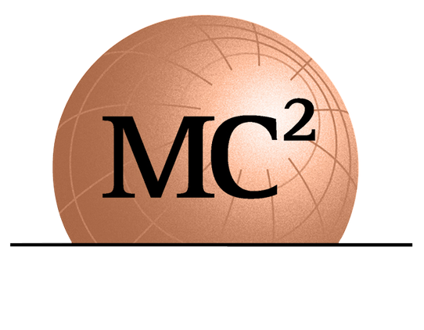
1275 SHILOH ROAD NW, SUITE 2620
KENNESAW, GA 30144
RSADLER@MC2ENGINEERS.COM
WWW.MC2ENGINEERS.COM

Job Title: Geotechnical Department Manager/Project Executive

Location: Tampa, Florida

Love Where You Work
Here at MC Squared, we know just how important it is to have a deliberate company culture with deep roots. We encompass safety, a positive attitude and a commitment to exceptional work quality in our day-to-day efforts; we take pride that our core values are Safety, Quality and a "Can-Do" attitude as we maintain our healthy and creative work environment. Our goal is to grow these roots for our next generation of likeminded professionals who embrace these values. That is why at MC Squared, our most important pillar is our people. We have a remarkable executive leadership team that will inspire and challenge you to learn and grow while you mentor our future generation of engineers and leaders. If you’re looking for a place to grow your career MC Squared’s strategic leadership, employee benefits, positive culture, and development opportunities are a great choice to spend the rest of your career.

About Us
MC Squared is a professional consulting engineering firm specializing in the fields of Geotechnical Engineering, Geo-Environmental, Construction Materials Testing and Inspection and Pavement Design and Management with offices in Florida, Georgia, and South Carolina. Our clients include DOT's, municipalities, state agencies and large multi-national engineering firms. We are retained to provide innovative solutions to complex subsurface issues to support the design of heavy civil infrastructure projects in the Transportation, Water/Wastewater, Tunneling, Dams and Aviation sectors, as well as provide cost-effective solutions for structures, commercial developments and educational institutions. MC Squared has experienced 30% growth year-over-year for the last several years and our current in-house projects and backlog show the trend will continue.

Geotechnical Department Manager/Project Executive Job Roles & Responsibilities:
- Lead safety efforts for team and ensure team follows safety rules and guidelines. Responsible for creating and modeling a safe work environment; demonstrating safety practices. Promote pre-task planning for all projects
- Mentor, develop and train staff both technically and for leadership roles
- Supervise and manage progress of all geotechnical projects to ensure quality and timely deliverables
- Manage the execution of geotechnical project assignments including supervising or performing complex engineering analyses, report review and report preparation. Critical review of field and laboratory test data as well as geotechnical recommendations.
- Oversight of and technical proposal preparation, management of client meetings and overall Client satisfaction
- Risk assessment and management at all levels including quality assurance of both technical and non-technical aspects of the department
- Risk assessment for both conventional and alternate delivery contracts
- Oversight and responsibility for Geotechnical design aspects including but not limited to:
  - shallow and deep foundations
  - tunnels (lined and unlined) and earth and rockfill dams
  - pavement engineering analyses and design, pavement management experience a plus
  - shoring and bracing systems for deep excavations
  - earth retaining structures
  - pipe/culvert foundations and machine foundations in water/wastewater, power and chemical plants
  - ground improvement and ground modification systems
  - groundwater dewatering and analysis, pump and slug tests
  - pile driving including knowledge in Pile Driving Analysis (PDA) and Case Pile Wave Equation Analysis Program (CAPWAP)
  - instrumentation systems and evaluation of data therefrom
  - seepage and deep excavations
  - seismic site class studies, liquefaction analysis, site-specific spectral response analysis
  - geo-forensic evaluations
- Contribute to increasing MC Squared’s geotechnical engineering consulting footprint in the market
- Bring advanced and insightful solutions to clients in Geotechnical Engineering
- Promote continuous quality monitoring and improvement on projects. Monitor quality standards and practices
- Senior level engineering professional providing technical direction required for production and completion of both routine and unique or complex projects
- Responsible for conceptualizing the initial design and/or investigative approach for a major phase of a large project or have overall responsibility for the engineering work on a project of moderate scope
- Plan, schedule, conduct, and/or coordinate engineering work involving conventional engineering practices but may include a variety of complex features such as conflicting design requirements
Company Perks + Benefits
In addition to offering competitive compensation, our employee benefits package includes:

- Four (4) Medical Plans effective first of the month following start date ($200/Mo. company paid)
- Dental Plan
- Vision Plans (50% Company Paid)
- Health Saving Accounts (HSA)
- Retirement Plan: 401(k) (3% Company Contribution)
- Short Term Disability (100% Company Paid)
- $50,000 Life Insurance (100% Company Paid)
- Accident Insurance (50% Company Paid)
- Critical Illness Insurance (50% Company Paid)
- GAP Insurance
- Profit Sharing & Bonus Program
- Eight (8) Paid Holidays
- Paid Sick and Vacation Time
- Professional development training
- Professional certification and registration renewals

Requirements
- Master of Science or PhD in Geotechnical Engineering, preferred
- 15+ years of relevant hands-on experience in heavy civil projects
- Knowledge of geotechnical software- APILE, LPILE, SLOPE/W or SLIDE, GRLWEAP, MSEW and PLAXIS required for slope stability, settlement, deep foundations and finite element modeling
- Conversant in both AASHTO (LRFD) as well as LFD/ASD procedures applicable for foundations, slopes and MSE Wall analyses
- Familiarity with FDOT and FHWA procedures for foundations, walls, and pavement analyses
- Familiarity with FL geology and local field and design practices is preferred
- Strong background in soil mechanics and foundation engineering, with extensive knowledge of geotechnical design and analysis combined with laboratory testing of soil, rock, concrete and asphalt
- Excellent analytical, written and verbal communication skills

Required Certifications
- Professional Engineer (PE)
- Membership in applicable Technical Associations

How to Apply
Please send your resume via e-mail to rsadler@mc2engineers.com. This is a full-time position housed in our office in Tampa, Florida. Must be authorized to work legally in the US.

EEO Statement
We are an Equal Opportunity Employer and do not discriminate against applicants due to veteran status or on the basis of disability. All qualified applicants will receive consideration for employment without regard to race, color, religion, sex, national origin, sexual orientation, or gender identity. Equality, Diversity, and Inclusion is at the heart of what we do! We are committed to creating an inclusive working environment for talented people of any background based on merit, fairness and respect.

COVID-19 vaccination is required for employment. However, accommodations per local and state government regulations will be considered.

Find your “why” at MC Squared! If your passion lies in working with a company that truly cares for your career development, that will challenge & inspire you and help you quickly progress in your career, consider MC Squared and apply today!

