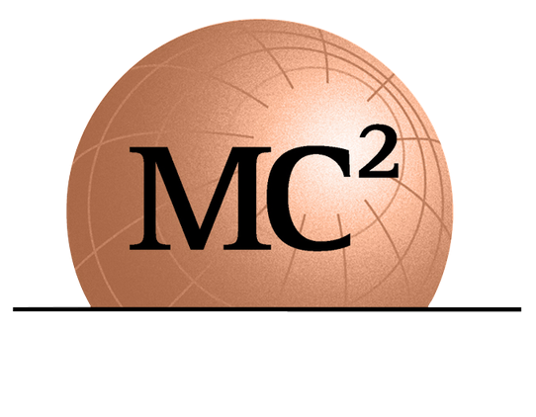
1275 SHILOH ROAD NW SUITE 2620
KENNESAW, GA 30144
RSADLER@MC2ENGINEERS.COM
WWW.MC2ENGINEERS.COM

Job Title: Geotechnical Laboratory Manager

Location: Kennesaw, Georgia

Love Where You Work!
Here at MC Squared, we know just how important it is to have a coherent company culture. Our firm is dedicated to safety, a positive attitude, and a commitment to exceptional work quality; we take pride in our culture that is driven by these core values of safety, quality, and a "Can Do" attitude. Our goal is to grow our team by onboarding people who either share these core values or possess the willingness and ability to embrace these values. That is why at MC Squared, our most important asset is our people. We have a remarkable executive leadership team that will inspire and challenge you to learn and grow. If you’re looking for a place to start or grow your career, our strategic leadership, employee benefits, positive culture, and development opportunities all make MC Squared a great choice.

About Us!
MC Squared is a professional consulting firm specializing in the fields of Geotechnical engineering, Geo-Environmental, Construction Materials Testing and Inspection, and Pavement Management with offices in Florida, Georgia, and South Carolina. Our clients include DOT's, municipalities, state agencies, and large multi-national engineering firms. We are retained to provide innovative solutions to complex subsurface issues to support the design of heavy civil infrastructure projects in the Transportation, Water/Wastewater, Tunneling, Dams, and Aviation sectors, as well as provide cost-effective solutions for structures, commercial developments, and educational institutions. MC Squared has experienced 30% growth year-over-year for the last several years and our current in-house projects show the trend will continue.

Position Summary
This position requires a BS. Or MS. college degree in civil engineering or equivalent. Laboratory certification is a plus and have at least 1-5 years experience in the field of laboratory testing related to geotechnical and materials testing. We prefer a successful candidate to have ACI and NICET certifications. Should you not have the required certifications you will need to acquire within 6 months of starting MC Squared.
Experience in geotechnical and materials testing lab work ranging from performing soil classifications, standard and modified proctors, grain size analysis, natural and organic content testing, Atterberg Limit testing, specific gravity, permeability, shrinkage limit, unconfined compression, Triaxial testing, consolidation, moisture content testing and compression strength testing of concrete and grout. Successful candidate will be responsible for calibration and maintenance of laboratory equipment and supervising all in-house testing as required by ASTM, AASHTO and GDOT. Successful candidate will be responsible for maintaining and procuring AMRL and CCRL certification for ASTM and AASHTO procedures for in-house laboratory by regularly testing proficiency samples and by performing tests. Heavy lifting of soils & concrete will be part of the day-to-day job. Maintain and organize project samples and equipment. Update all SOP (standard operating procedures), TOP (technical operating procedures) and QMS (quality management systems). Perform technician audits and reviews. Assist in radiation safety officer duties when needed. Familiarity with laboratory data entry software such as gINT is a plus. Familiarity with MS Office (Excel) is a plus.
Requirements
- BS or MS degree in Civil Engineering or equivalent with concentration in Geotechnical Engineering or Construction Management
- 1-5 Years’ experience

Preferred Certifications
- Professional Engineer (PE), Professional Geologist (PG) or similar professional registration/certification relevant to the type of services and projects being managed, a plus
- ACI, a plus
- NICET, a plus

How to Apply
Please send your resume via e-mail to rsadler@mc2engineers.com. This is a full-time position housed in our office in Kennesaw, Georgia. Must be legally authorized to work in the US.

EEO Statement
We are an Equal Opportunity Employer and do not discriminate against applicants due to veteran status or on the basis of disability. All qualified applicants will receive consideration for employment without regard to race, color, religion, sex, national origin, sexual orientation, or gender identity. Equality, Diversity, and Inclusion is at the heart of what we do! We are committed to creating an inclusive working environment for talented people of any background based on merit, fairness and respect.

Please note that COVID-19 vaccination is required for employment but that we will consider accommodations per local and state government regulations.

Find your “why” at MC Squared! If your passion lies in working with a company that truly cares for your career development, that will challenge & inspire you and help you quickly progress in your career, consider MC Squared and apply today!

